**Ajay Kumar Garg Engineering College, Ghaziabad**

**Central Library**

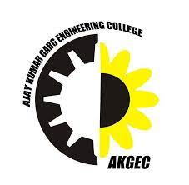

**Estd.1998**

**4.2.1: Library is automated using Koha Integrated Library System** **(KOHA)**

(Additional Information)

* Screen Shots of KOHA used in Institute.
* Year wise Bills for the purchase of LMS.

**Ajay Kumar Garg Engineering College, Ghaziabad**

**Central Library**

**Screen shot of KOHA Software**

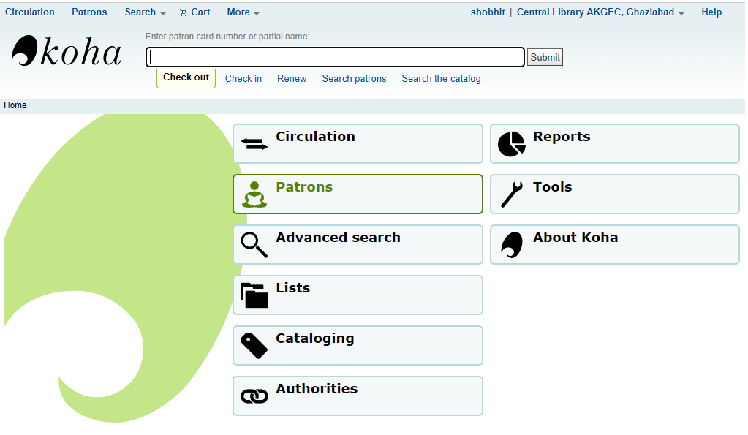

**Koha Software Main Page**

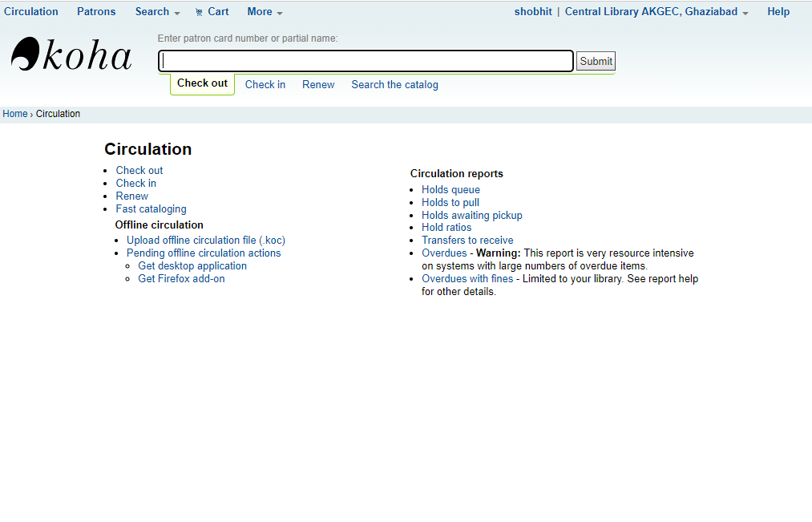

**Issue / Return (Circulation Page)**

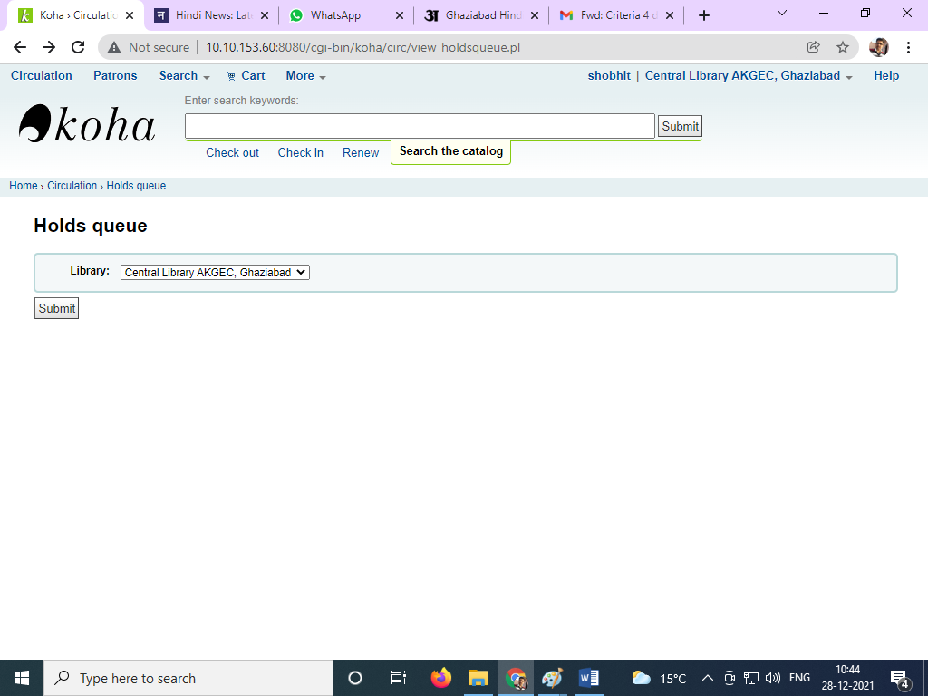

**Book Reservation**

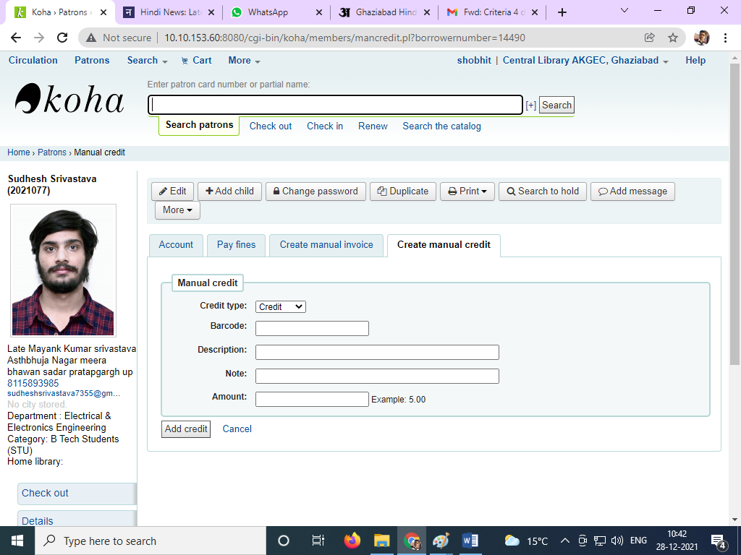**Fine Receipt**

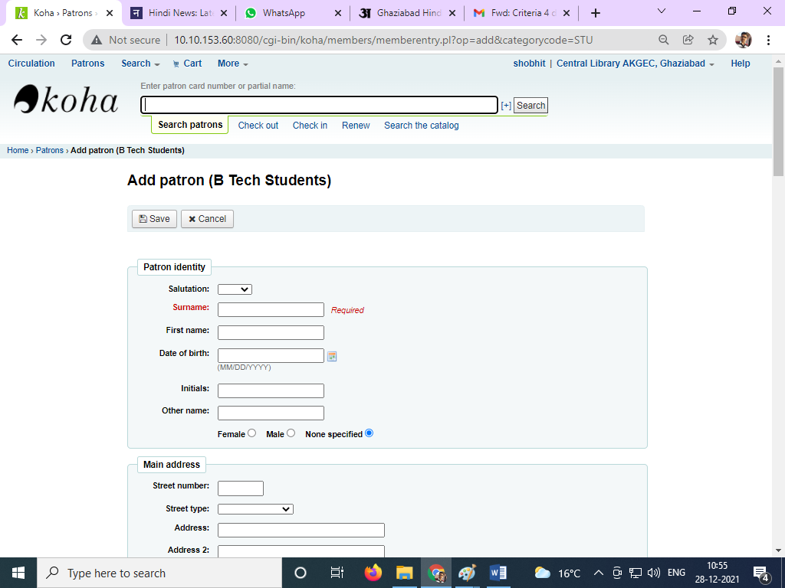

**New Member Registration page**

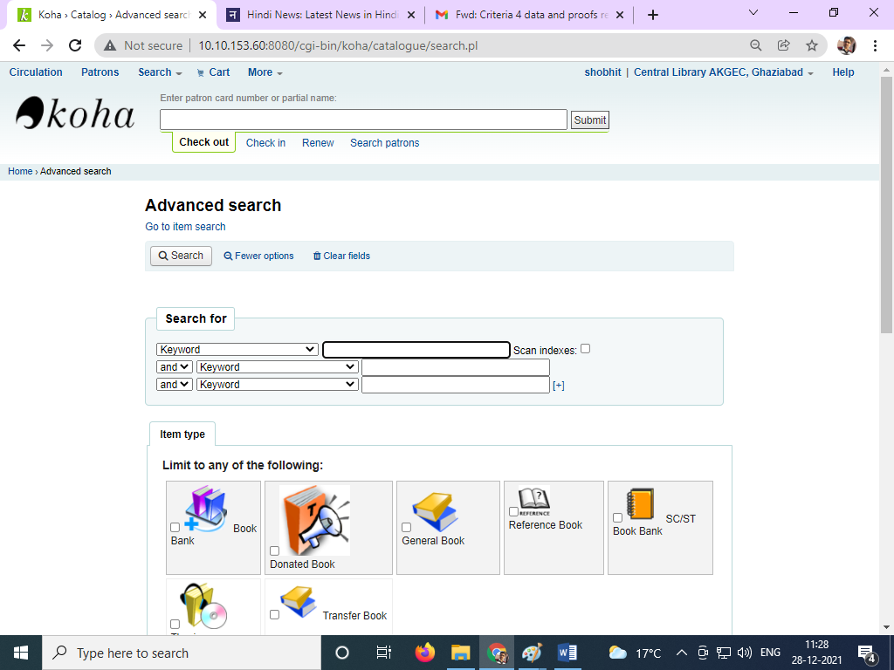

**Online Search for Books**

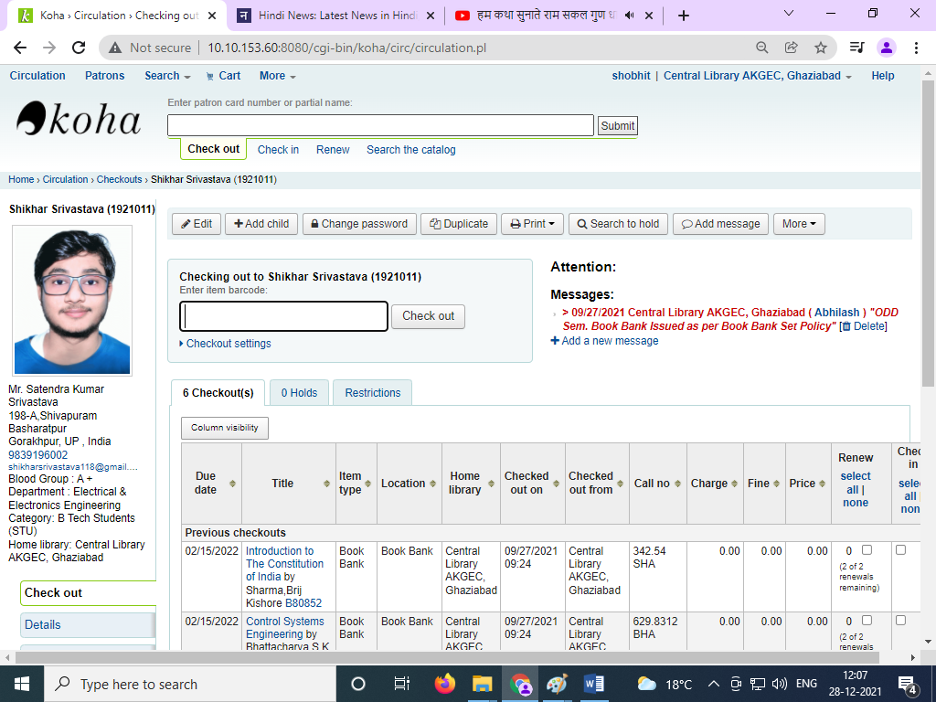

**Student Information page**

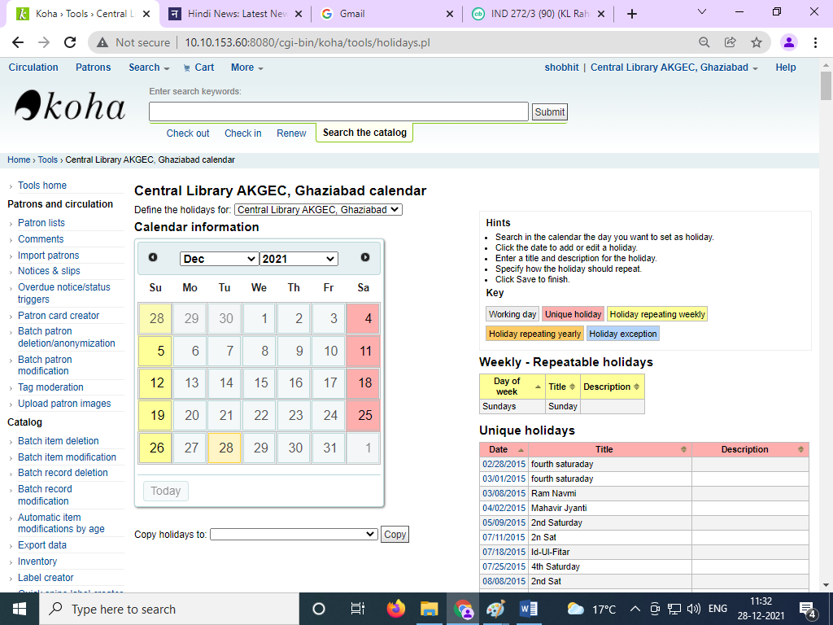

**Calendar Information page**

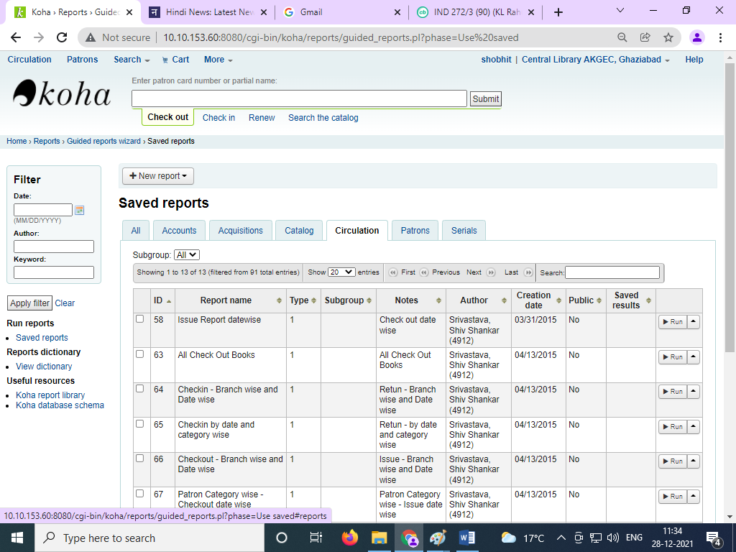

**KOHA Report Page**

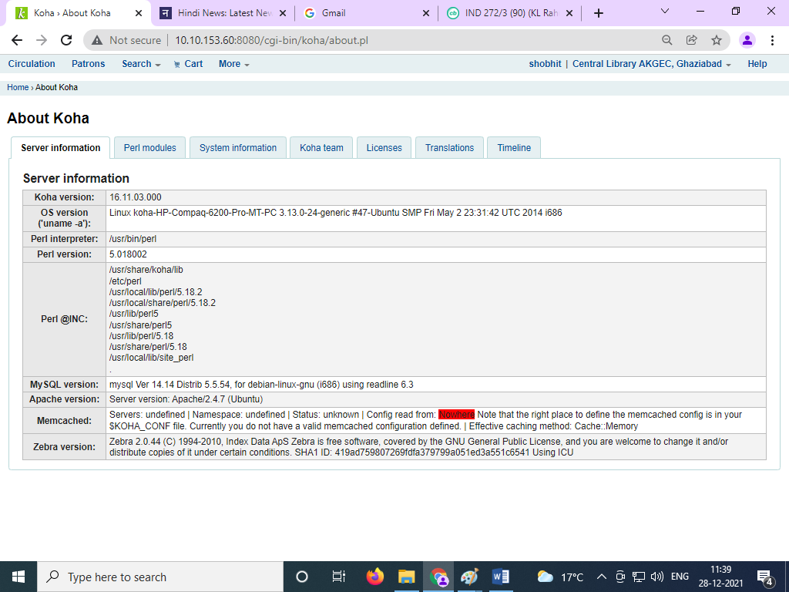

KOHA Information Page

**Ajay Kumar Garg Engineering College, Ghaziabad**

**Central Library**



**Estd.1998**

**4.2.1: Library is automated using Koha Integrated Library System** **(KOHA)**

**2014-15**

**(Relevant Bills)**





**Ajay Kumar Garg Engineering College, Ghaziabad**

**Central Library**



**Estd.1998**

**4.2.1: Library is automated using Koha Integrated Library System** **(KOHA)**

**2017-18**

**(Relevant Bills)**



**Payment After 60% Discount**

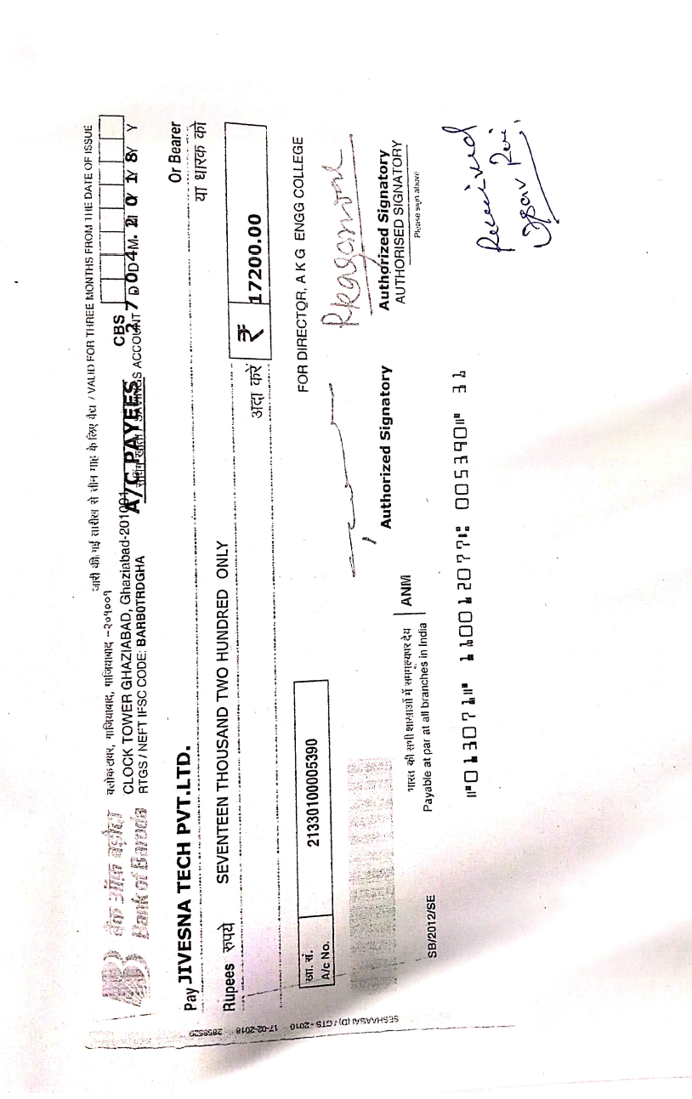

**Ajay Kumar Garg Engineering College, Ghaziabad**

**Central Library**



**Estd.1998**

**4.2.1: Library is automated using Koha Integrated Library System** **(KOHA)**

**2018-19**

**(Relevant Bills)**





**Ajay Kumar Garg Engineering College, Ghaziabad**

**Central Library**



**Estd.1998**

**4.2.1: Library is automated using Koha Integrated Library System** **(KOHA)**

**2019-20**

**(Relevant Bills)**





**Ajay Kumar Garg Engineering College, Ghaziabad**

**Central Library**



**Estd.1998**

**4.2.1: Library is automated using Koha Integrated Library System** **(KOHA)**

**2020-21**

**(Relevant Bills)**

